Oak Park Neighbourhood Centre Theory of Change Mission, Vision & Outcomes

A welcoming community, supporting each other through diverse programs & resources to build friendships, strengthen one another & create healthy neighbourhoods.
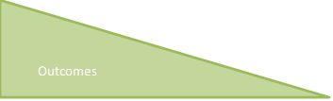 | Support, Connect, Engage  - People Belong,  - Families are Strong,  - Neighbours Care,  - Everyone Shares
Family Bonds, Positive Social and Skill Development | Learning, play & exercise
 | Demonstrate & support parent skills & behaviour guidance.
 | Increase family bonds
Meaningful opportunities to serve | Encourage & provide support for people to get involved
 | Sharing of skills & knowledge
 | Develop & demonstrate empathy
Friendship & mutuality among people of different backgrounds | Share traditions, stories, art, culture, celebration & heritage
 | Participants reflect community
 | Opportunity for community synergies
 | Neighbours build meaningful relationships
 | Welcoming, safe, supportive environment
Support & connection to meet Needs | Support individuality, self-esteem & confidence
 | Help with community strategies
 | Mentor groups to contribute
 | Support during personal challenges
 | Space & programs that reflect community need
 | Referrals

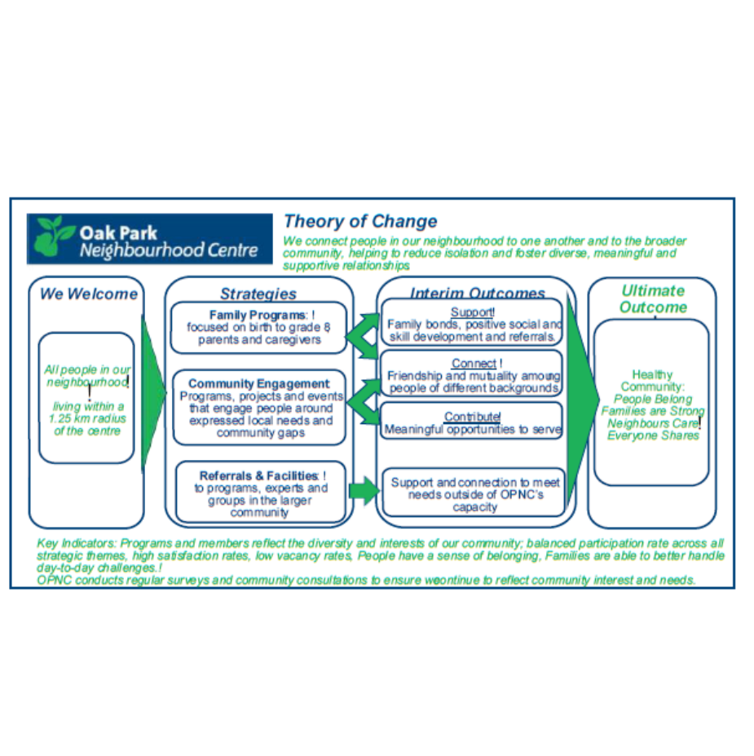

OAK PARK NEIGHBOURHOOD CENTE

History, Vision, Mission, Program Overview
Support, Connect, Engage. People Belong, Families are Strong, Neighbours care, Everyone Share

We are a registered charity, community-based agency that began in 1999 with 6 women meeting together and in the last 26 years we have supported 22,800 people, currently serving over 5,111 people a year.
We have an inviting, non-institutional, barrier free spaces, so that they are welcoming to everyone. Programs are a reflection of the needs, talents and gifts of our neighbours and friends to be inclusive, asset supporting and relevant to the whole community. We believe in supporting the whole community together, regardless of income level, age or background.

Our centre has various programs including multicultural programs (Mandarin, Japanese, German, Arabic); food programs, household supports, infant pantry, harm reduction & supports, poverty support group, utility bill payments, financial literacy, year-round income tax, mobility equipment, seniors, and supports for people with disabilities. We run family, infant, toddler, preschool, school age, youth and seniors’ programs. We provide free or affordable space to a number of local agencies and businesses to provide programs.

We are a welcoming community, supporting each other through diverse programs & resources to build friendships, strengthen each other & create healthy neighbourhoods.

To relieve poverty, provide education, support, recreational & social opportunities for people of all abilities and ages.
- To relieve poverty by providing basic amenities - food, education, counselling and clothing.
- To provide education and support
- To provide educational, recreational, and social opportunities for the community.

